**End to End EMR Setup on AWS**

**Step 1: First create and download a Key Pair for EMR from EC2**

In Search type EC2 and select EC2

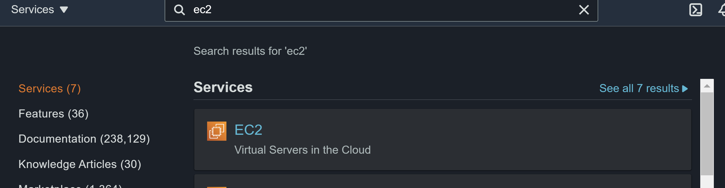

Click on Key pair

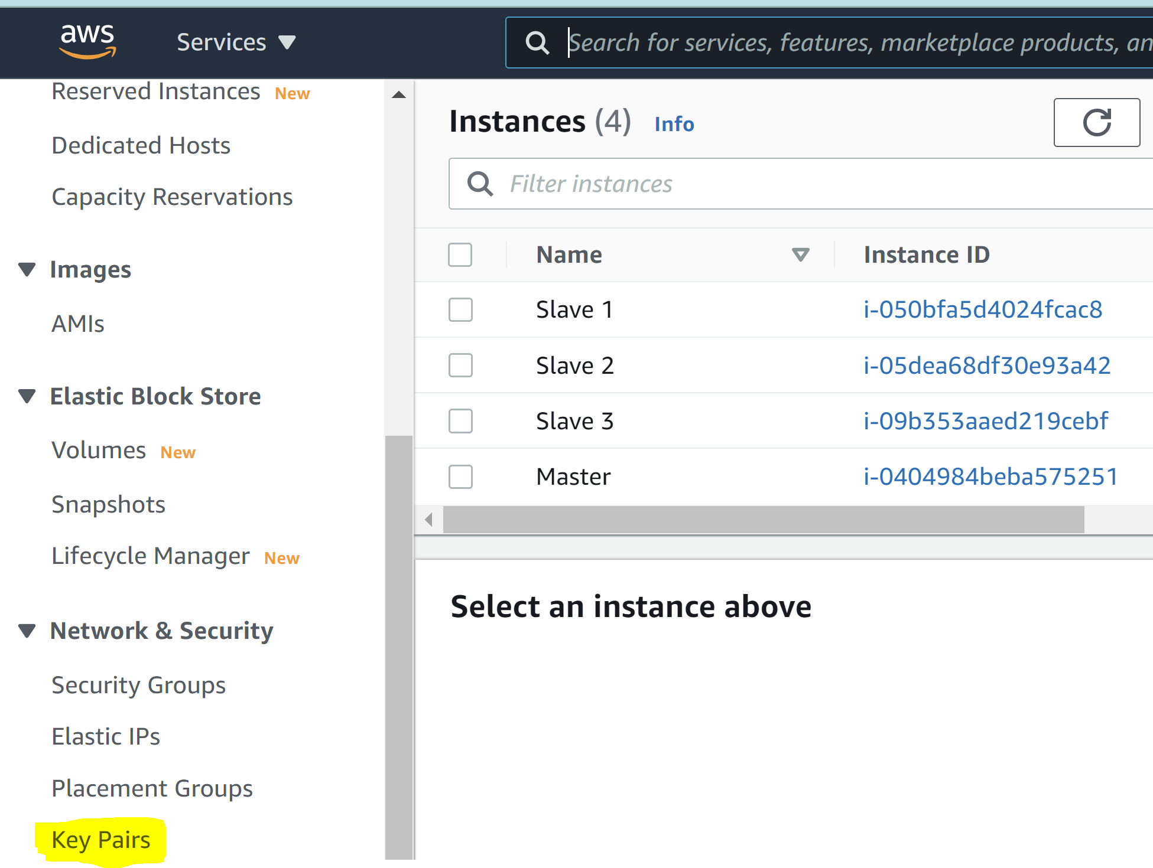

And Create your Key Pair: I have created as Hadoop and saved it

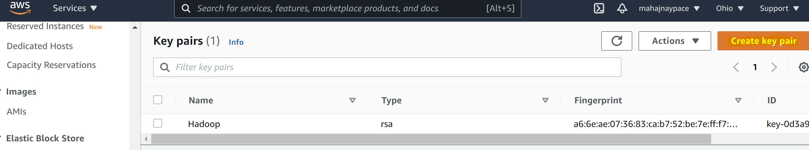

**Step 2: Create your cluster for Master and Slaves**

Now go back to EMR

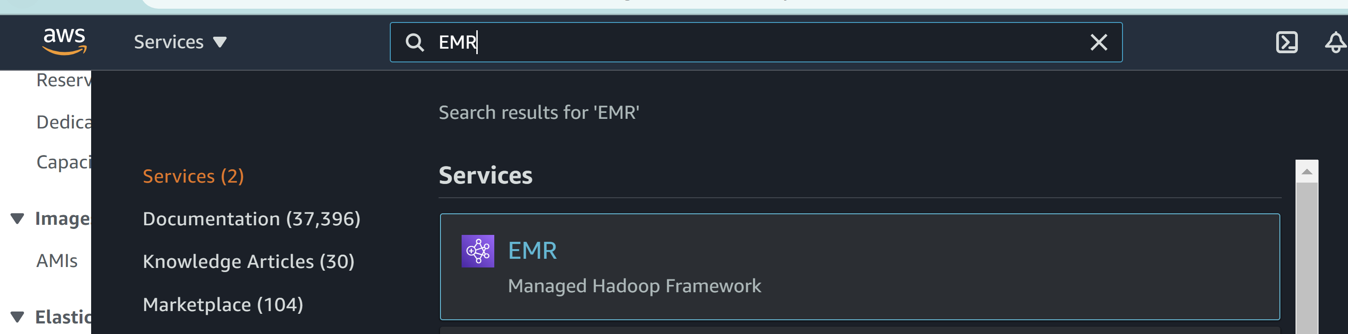

Click Create Cluster

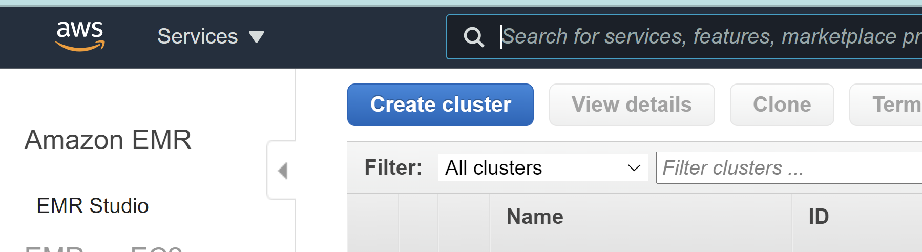

Select the configuration settings as below:

**Cluster Name**: Hadoop (you can put your own cluster name, I have given as Hadoop)

**Software configuration:** Select the latest version (it comes with inbuild Hadoop, Hive, Hue, Pig and Tez software’s. So, no need to do configuration inside the instance as we did in EC2 Settings)

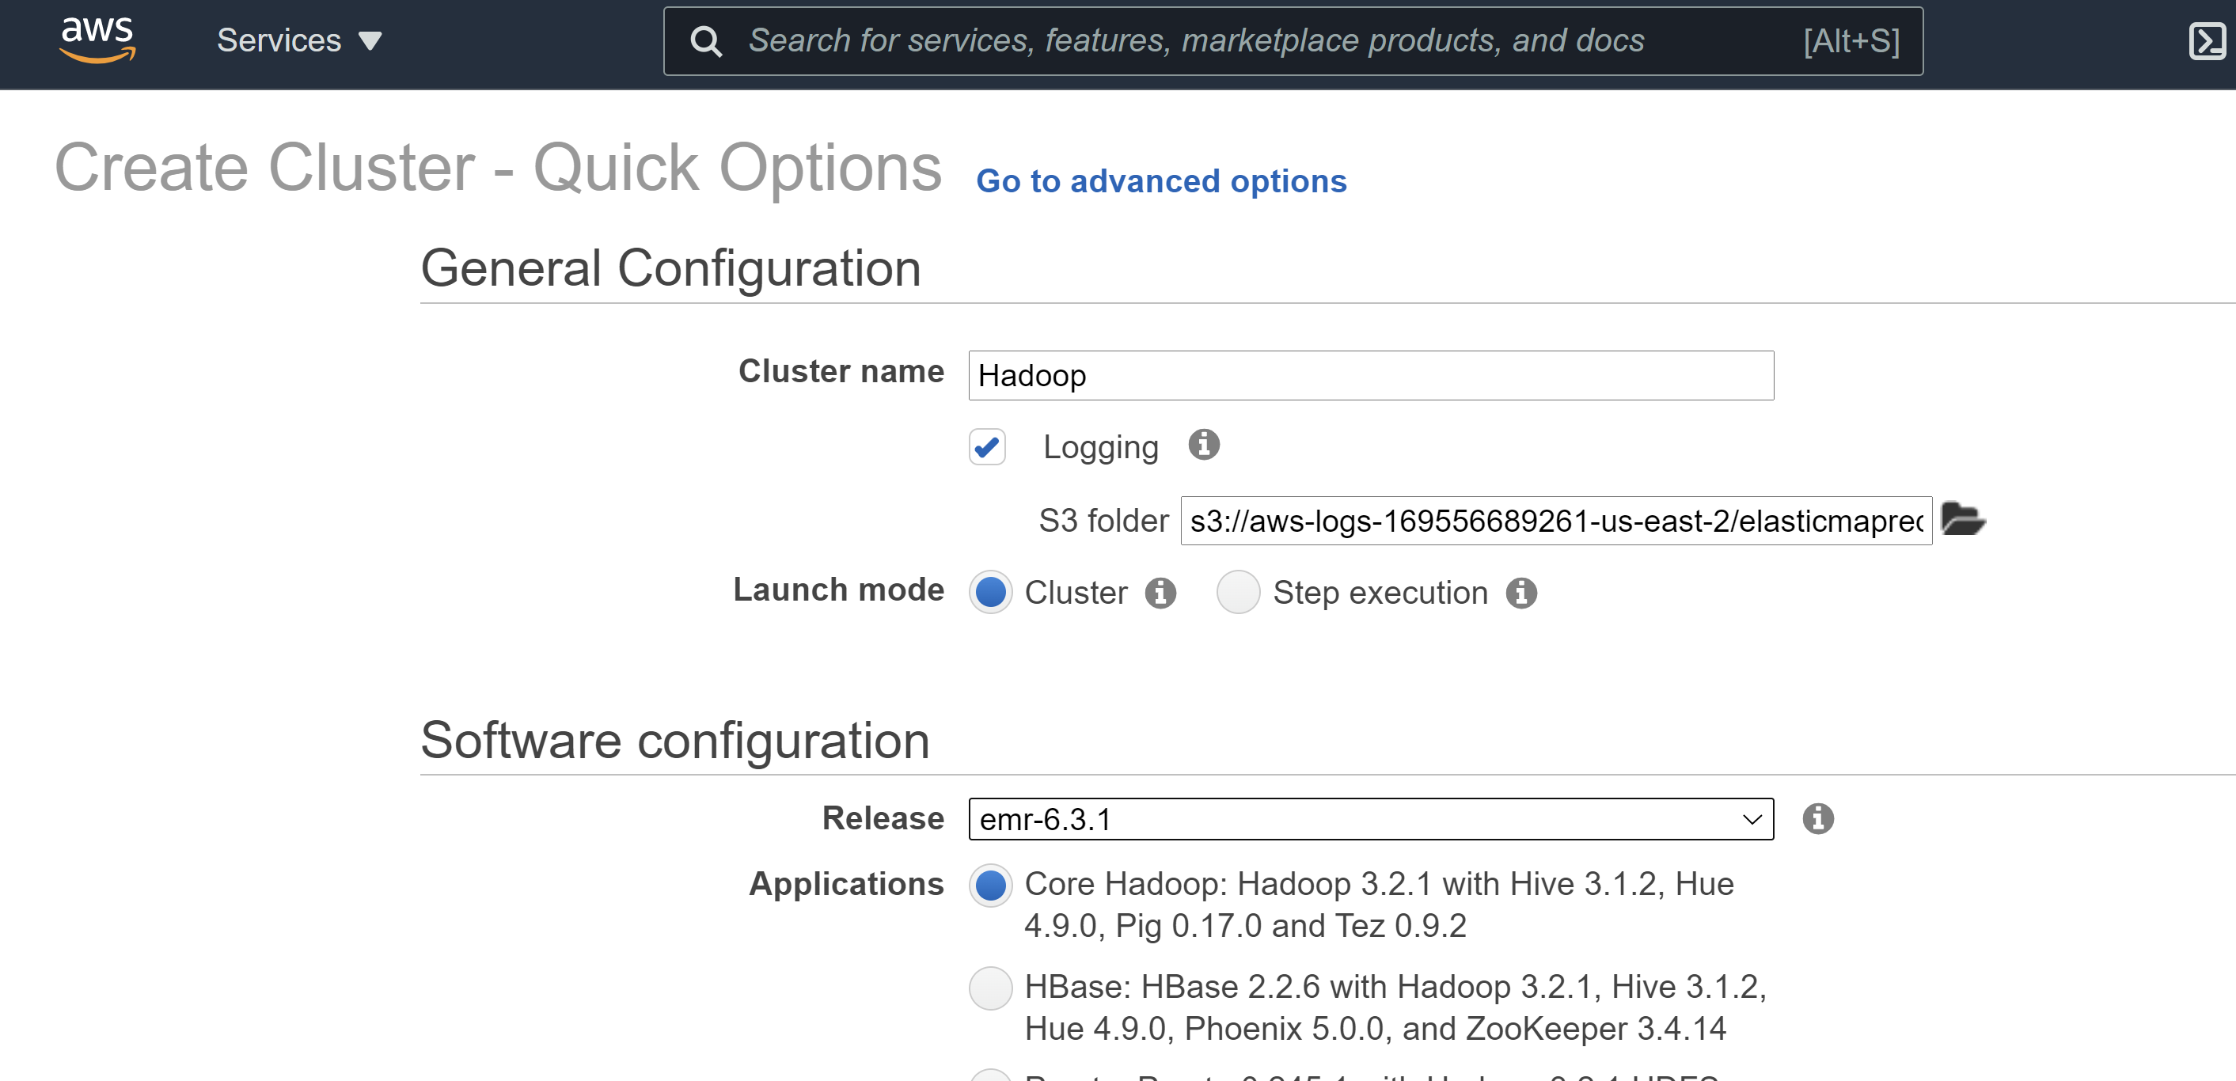

Select Hardware configuration as below:

**Instance Type**: m5.xlarge

**Number of instances**: 4

**Auto Termination: It should be ticked of or else everytime the time is out it will auto terminate your session**

EC2 Key pair: Hadoop (Select the EC2 key pair we created at the first step)

**Then click on Create Cluster**

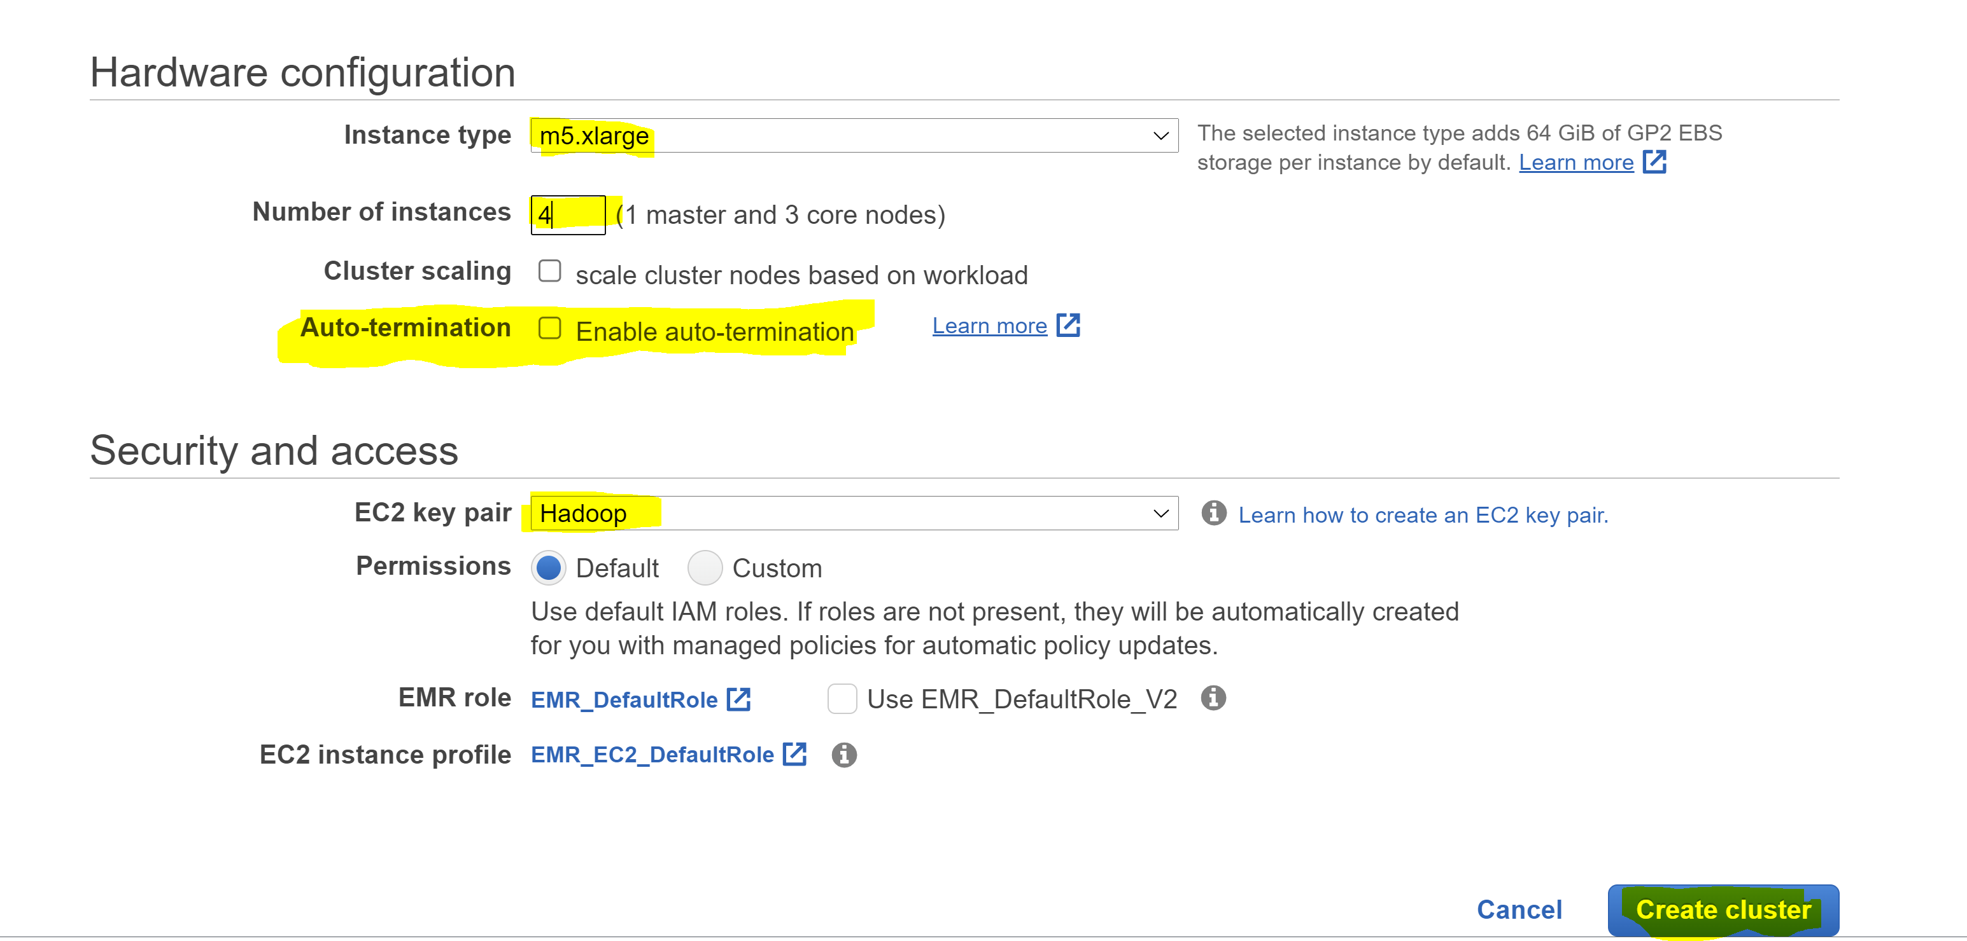

**Step 3: Setup SSH**

Click on Cluster and then View cluster details

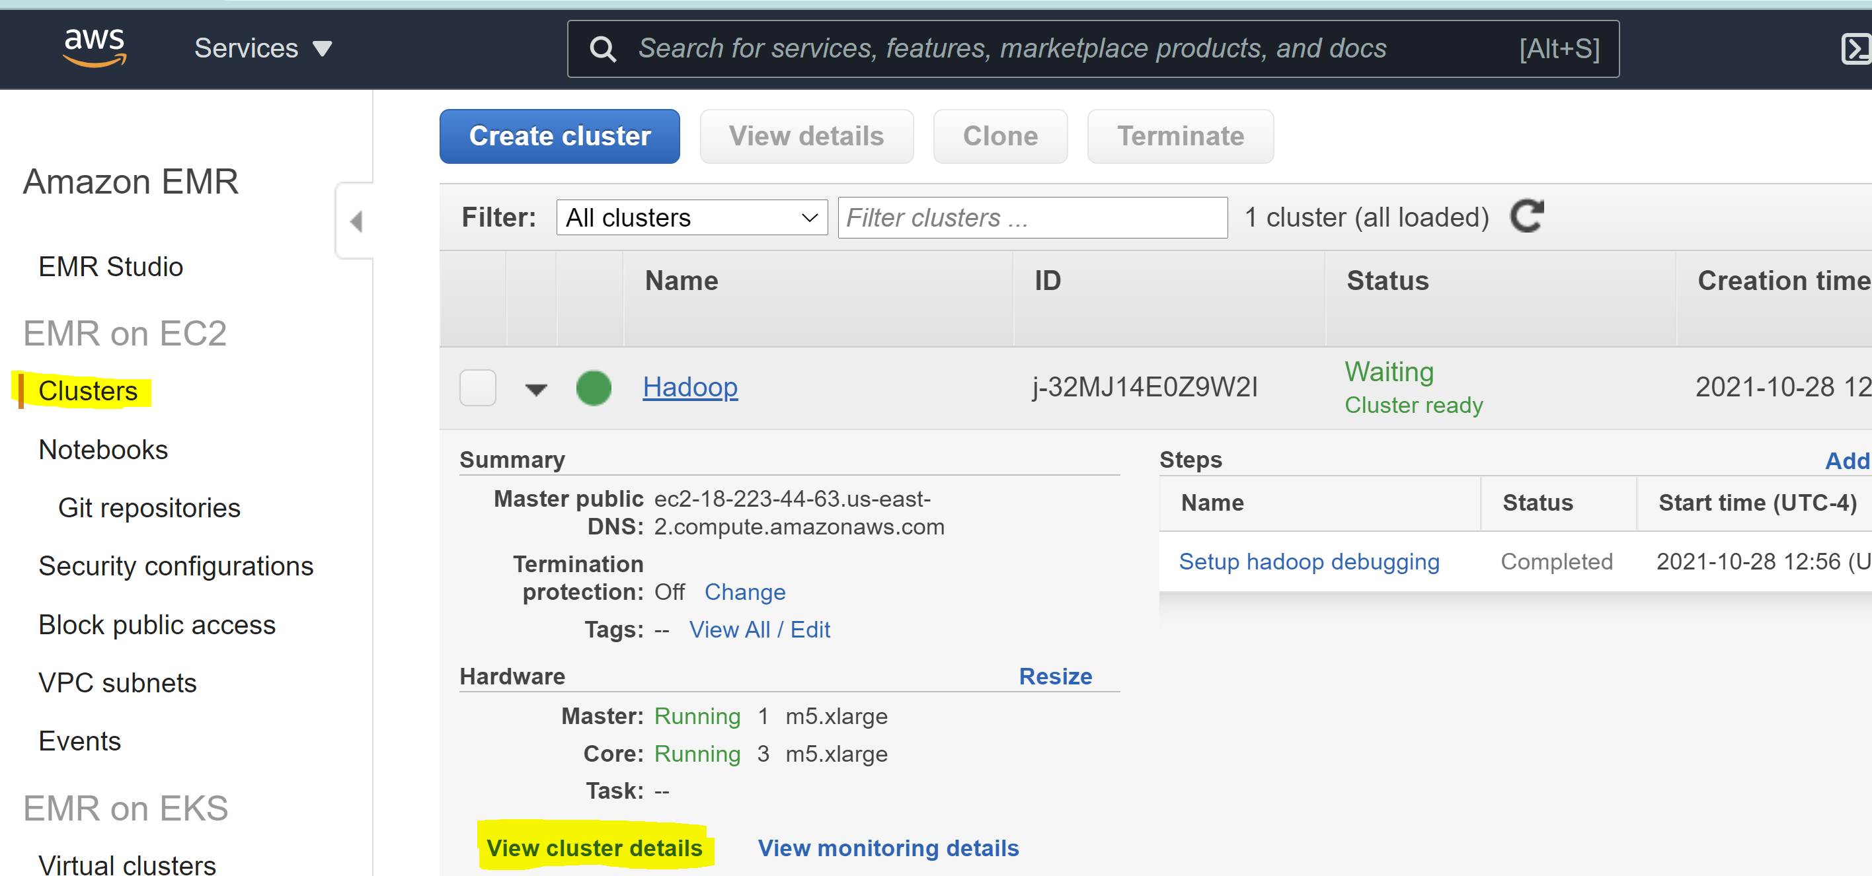

On Cluster details go to Security and access

Then click on Security groups for Masters as highlighted in yellow below

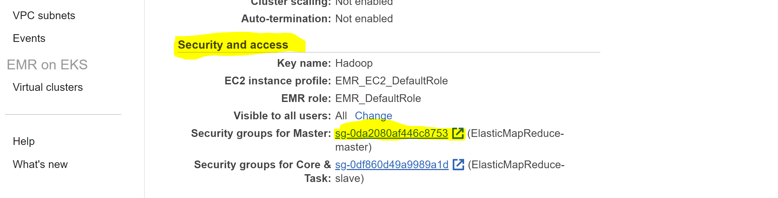

Now CLICK the master node **Security group ID**

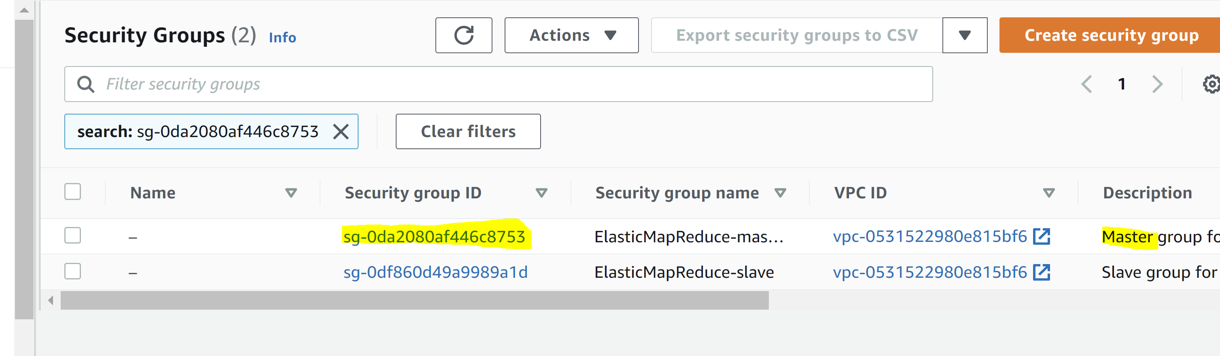

Here we have to edit Inbound rules:

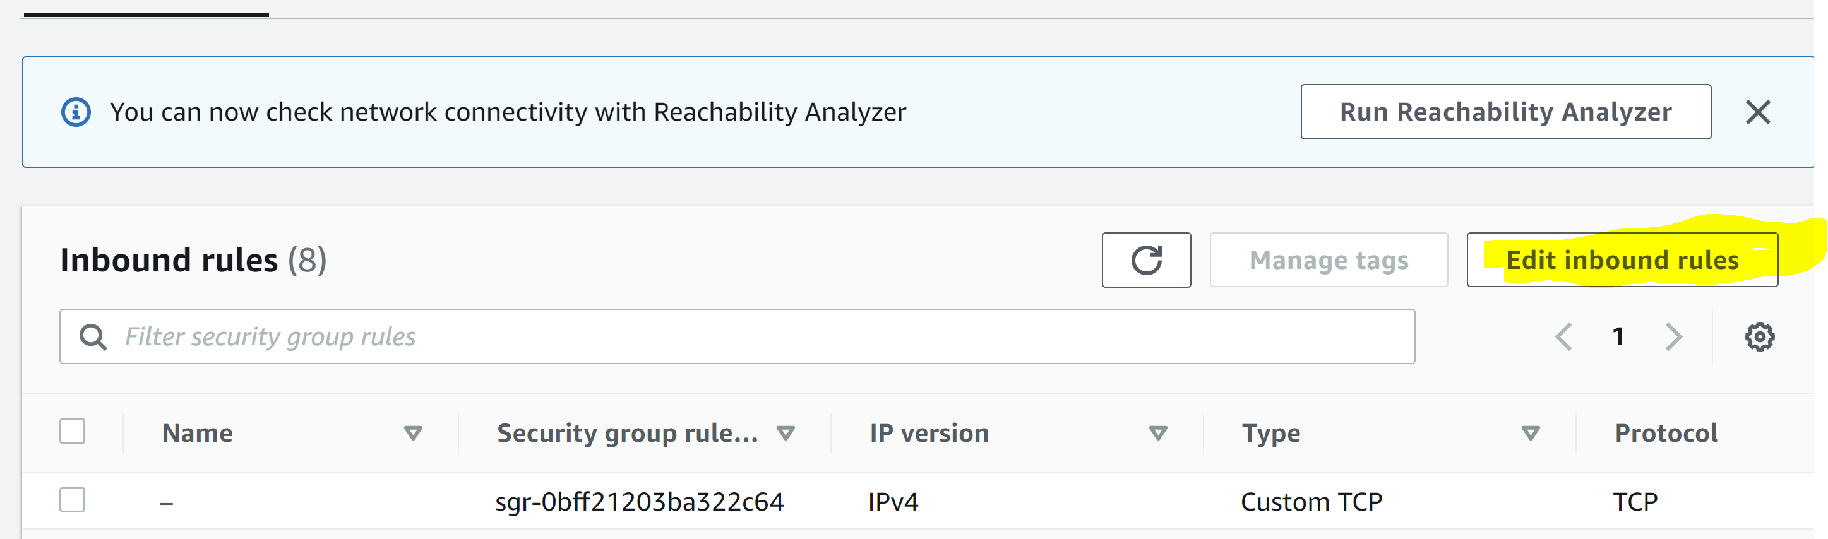

Click on add rule



And add SSH rule as below



Save your rule



Then Go back to EC2 you should be able to see your instances up and running

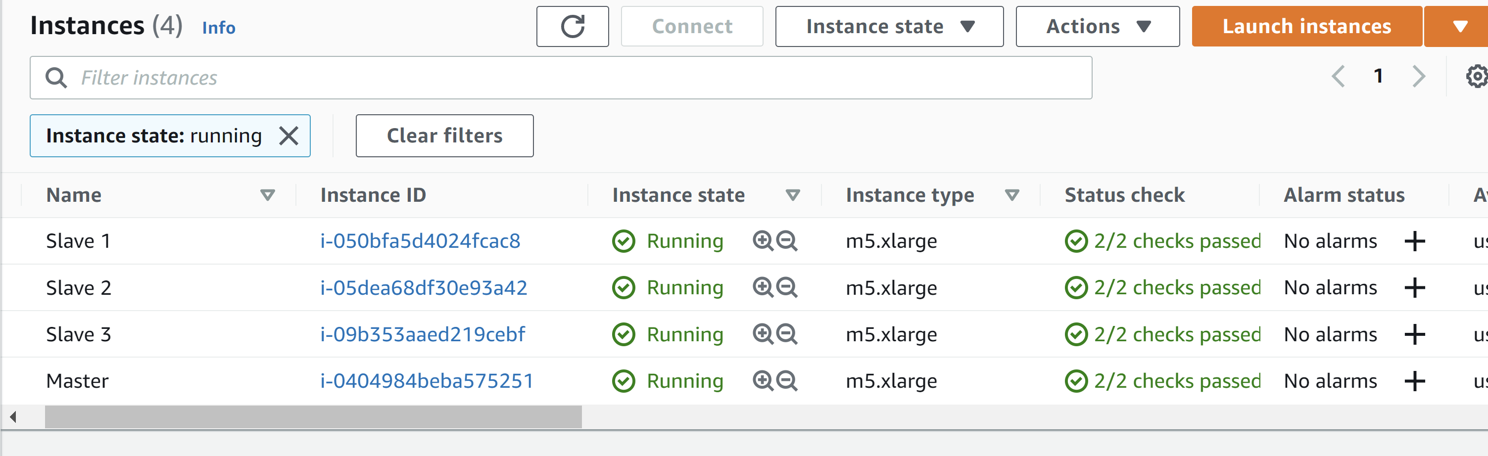

**Step 4: Select your master instance and connect to EMR**

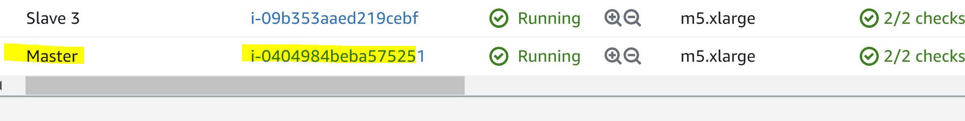

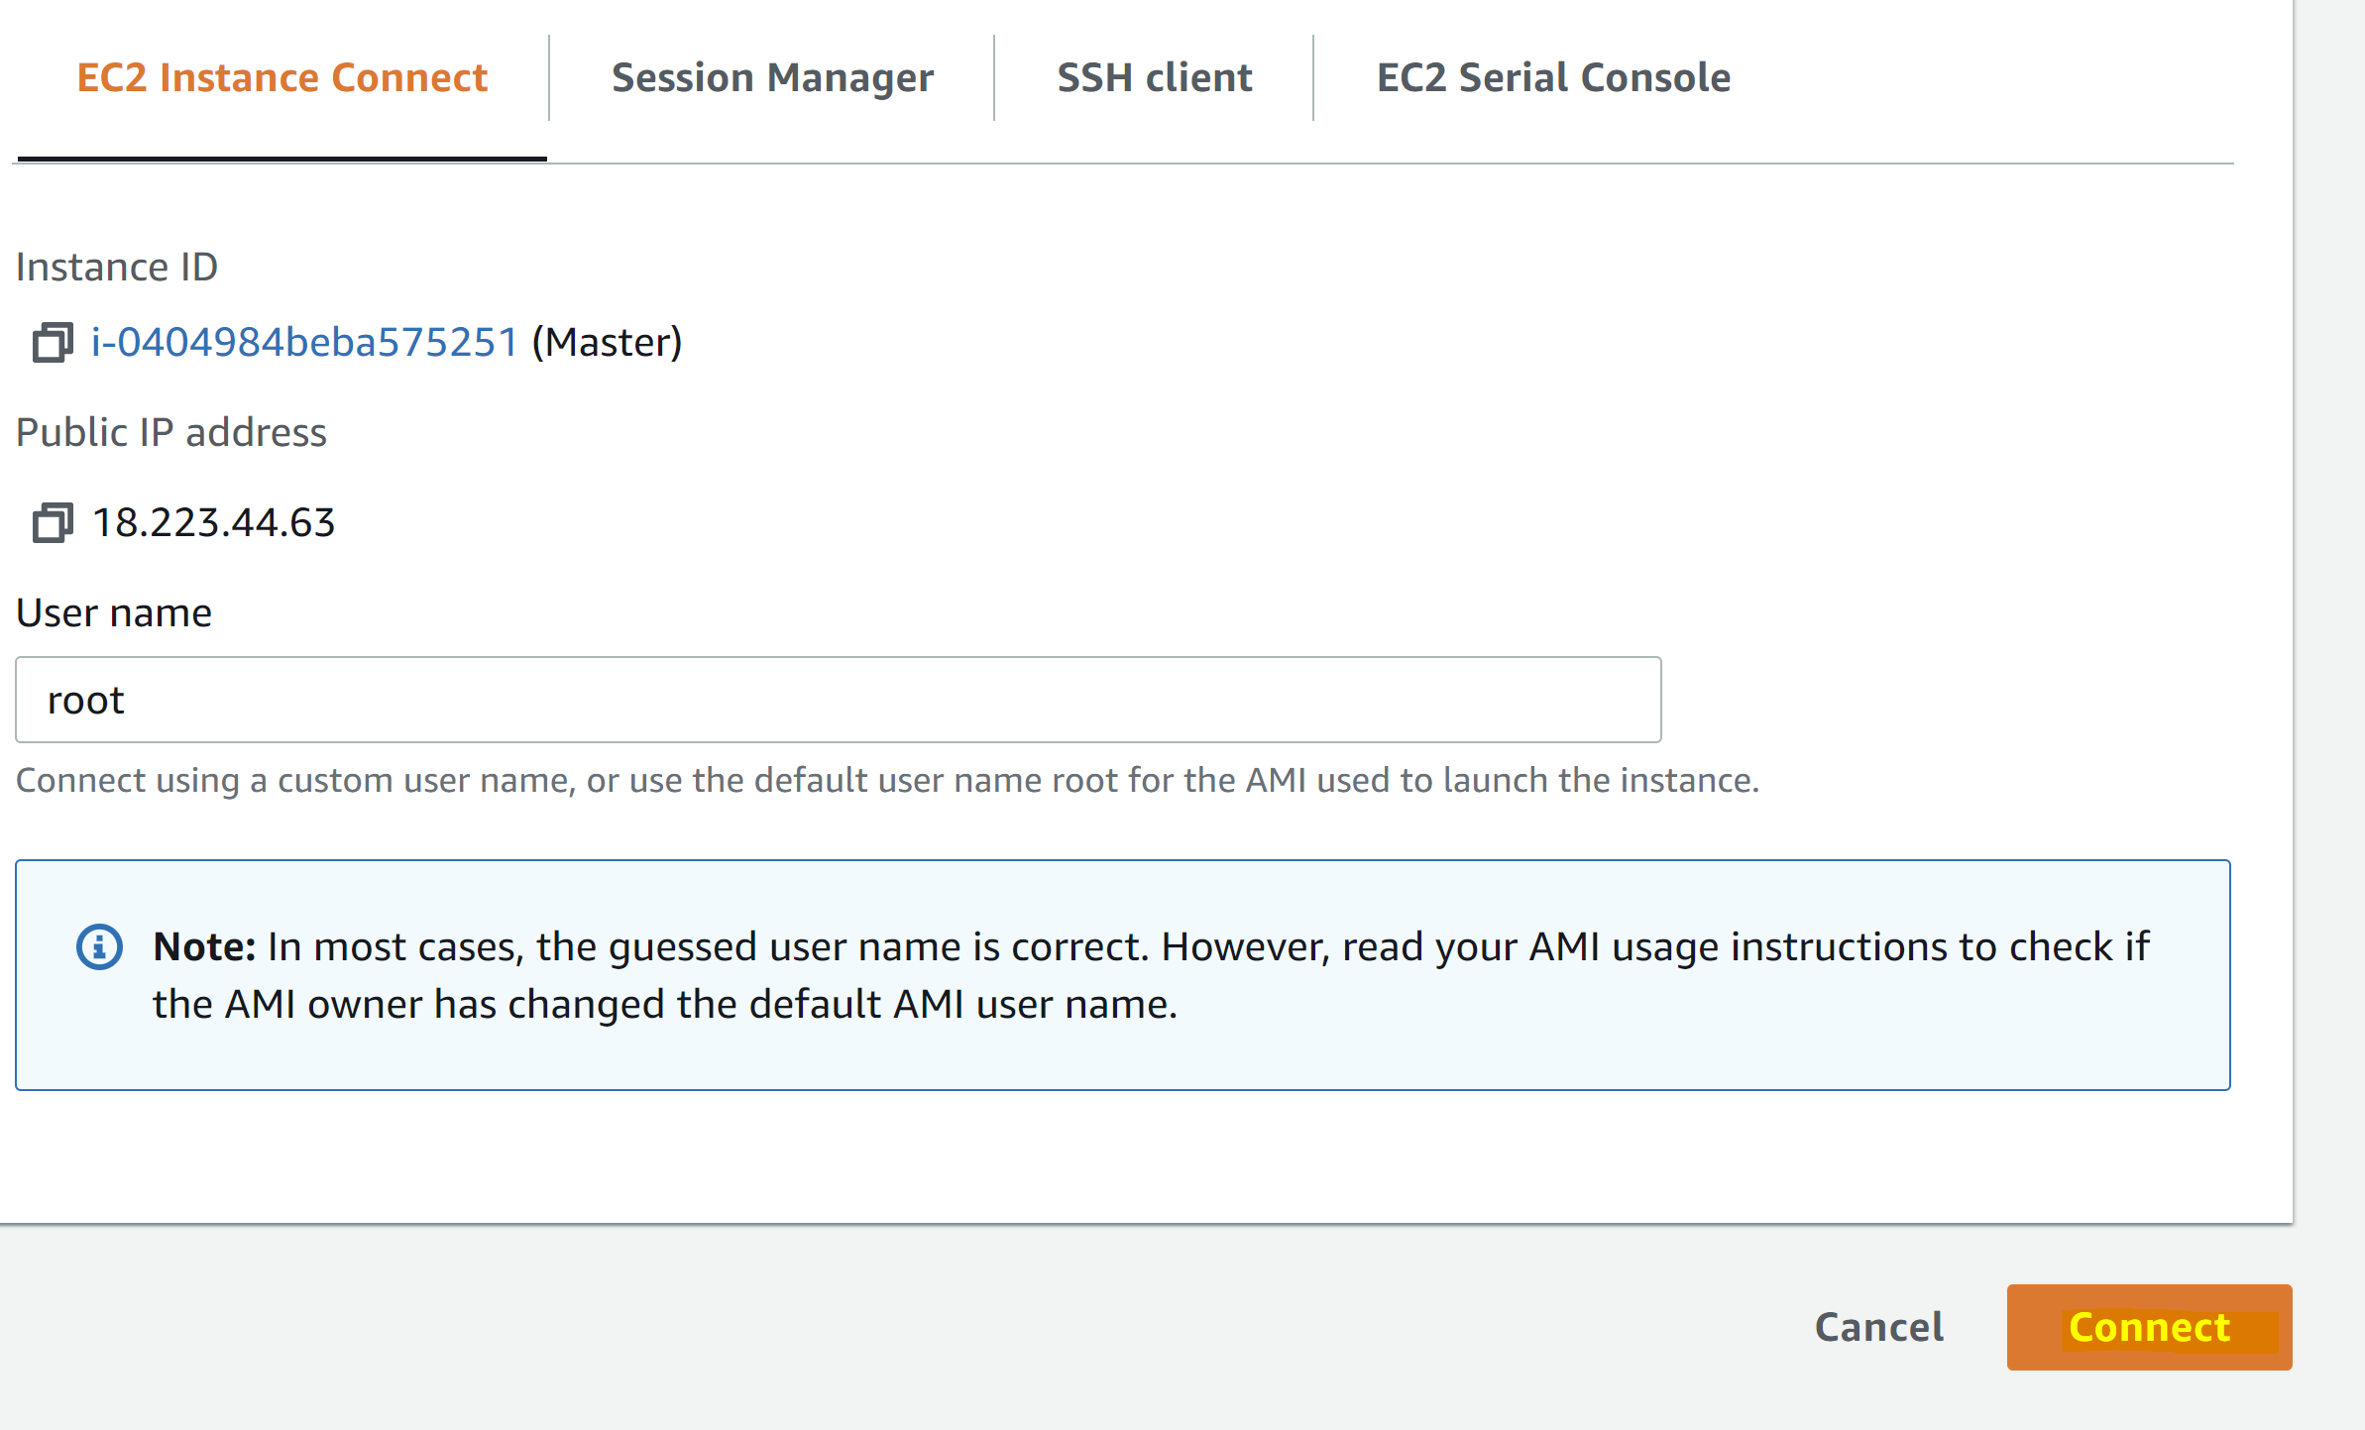

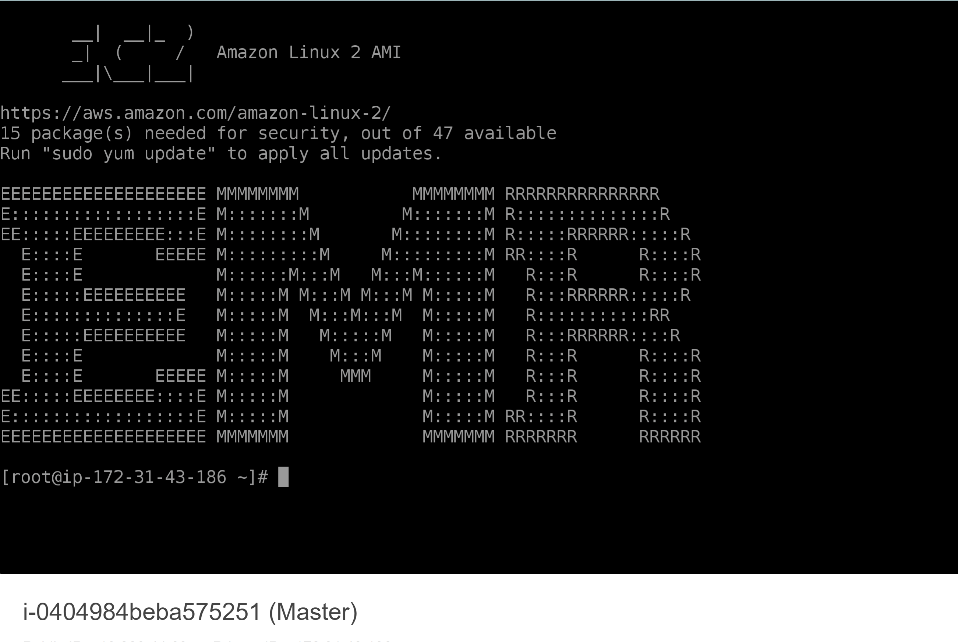

Alternatively, you can login to EMR via PuTTY

**Step 1: Download PuTTY for Mac or Windows and install. Once installed you should be able to see a screen as below**

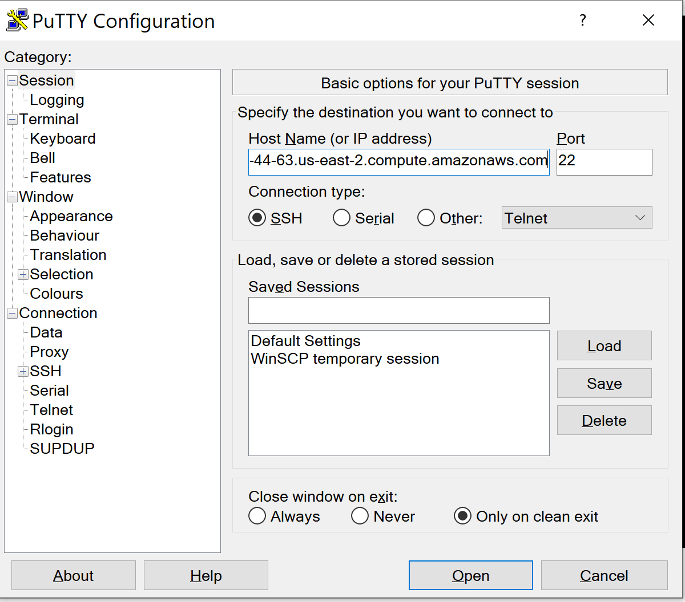

**Step 2: Paste your Master’s IP DNS address inside Hostname**

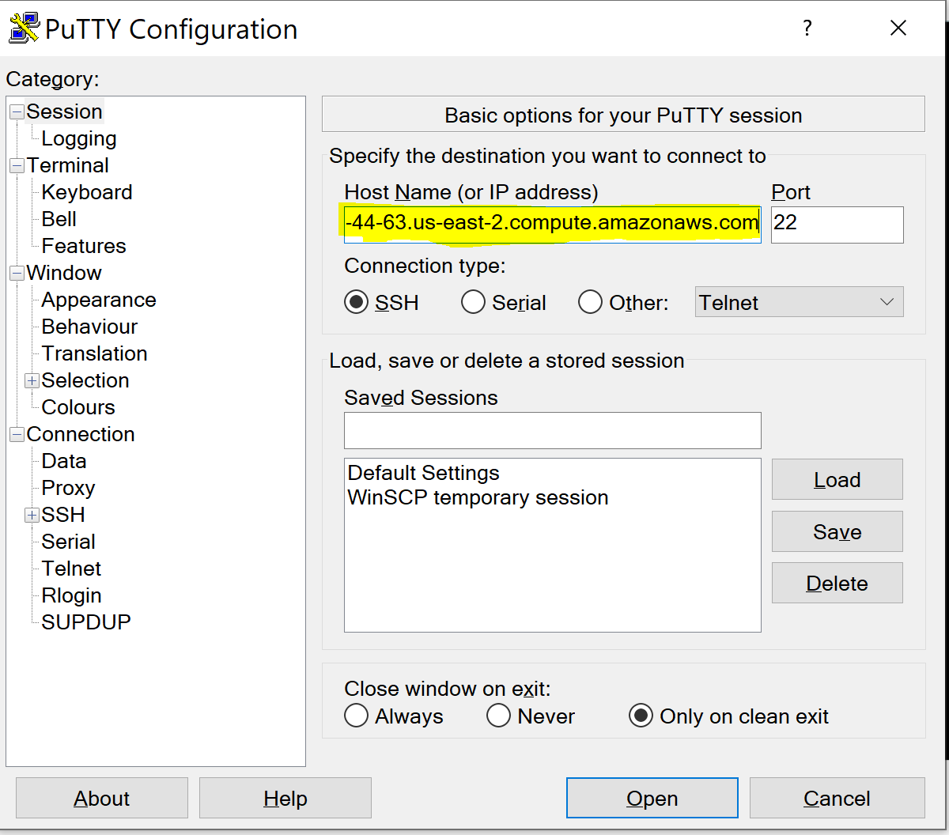

**Step 3: Establish a connection via SSH**

Click on SSH, under SSH select Auth

Insert your Private Key **(same as EC2 Key pair we used during EMR Setting)**

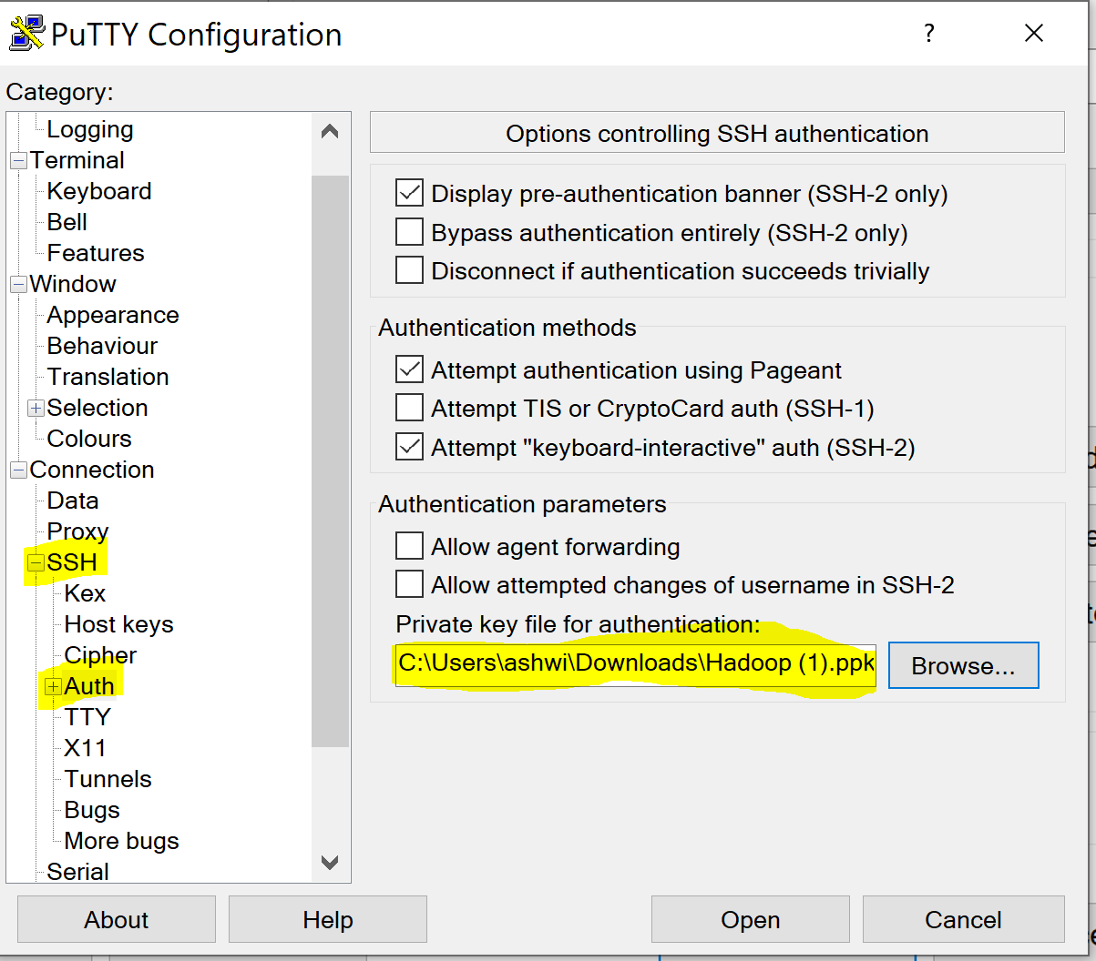

**Step 3: Set your username**

Select data and insert your username as **ec2-user** in Auto-login username

Click Open

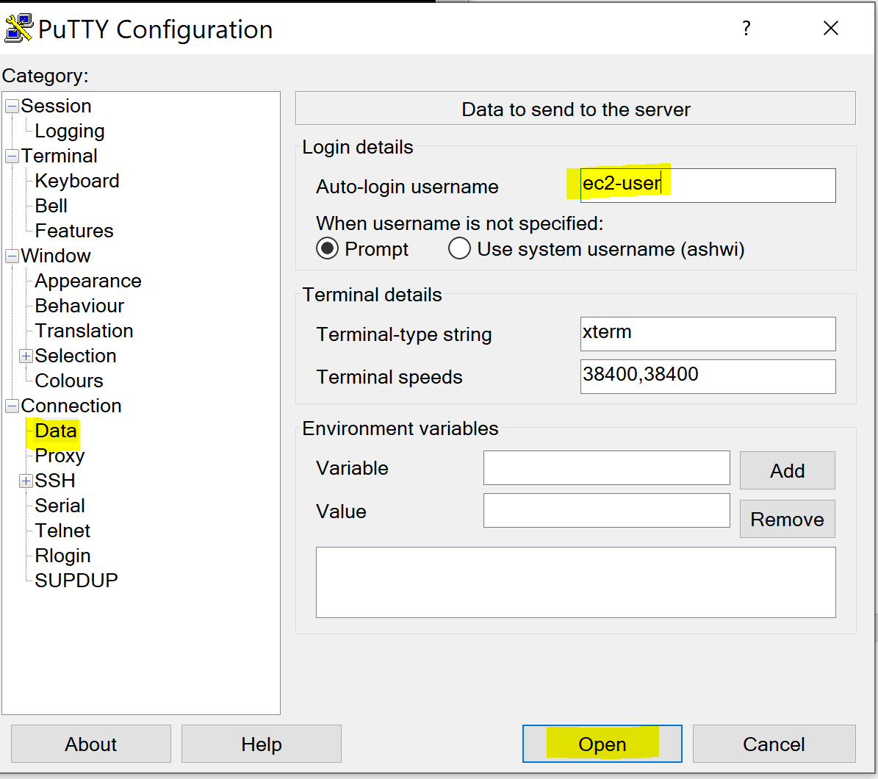

**You should be able to see below screen**

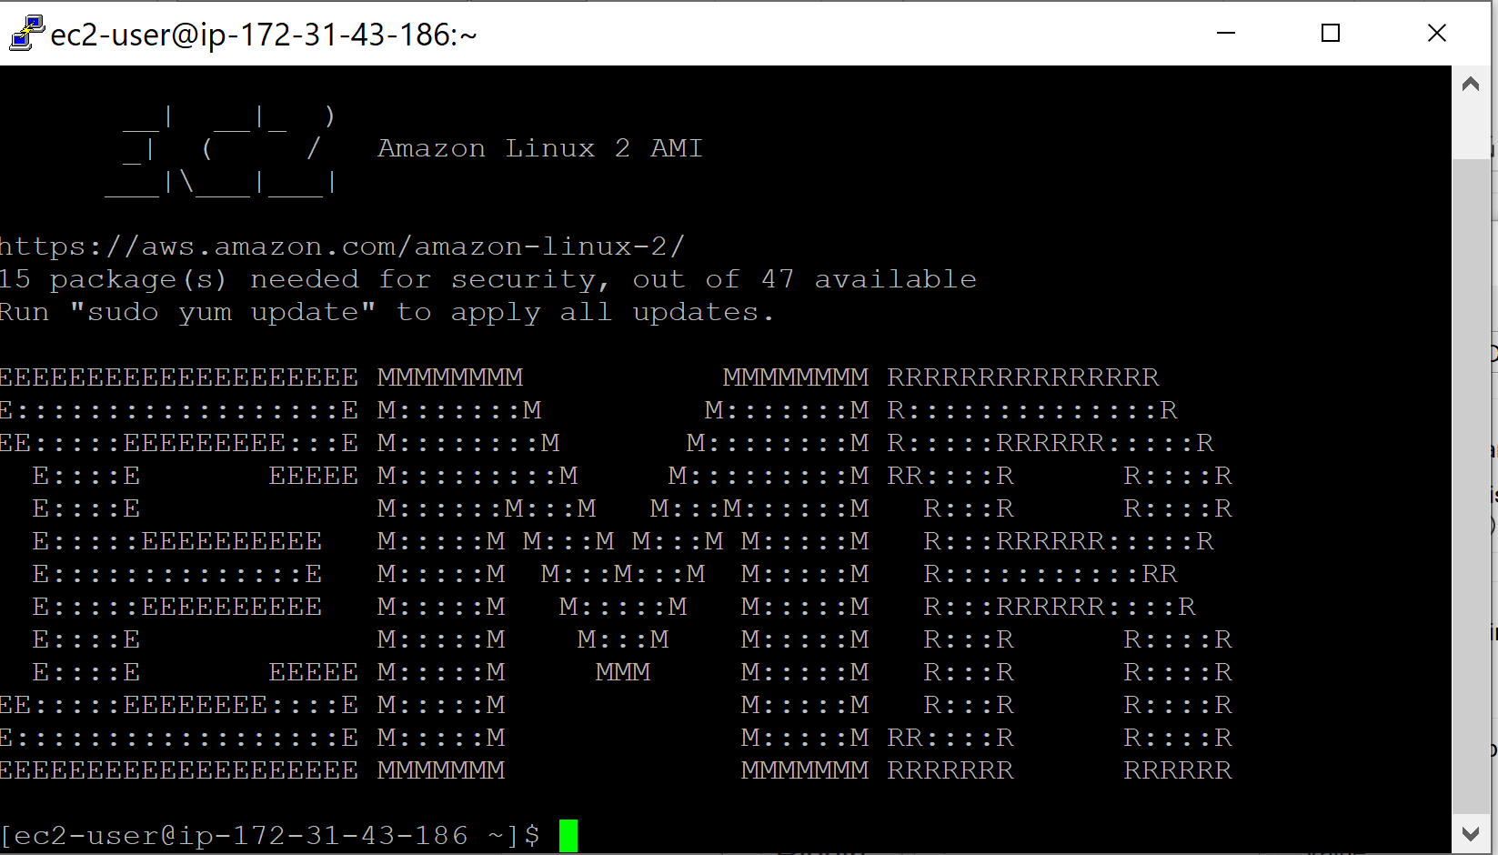

**Hope this helps!!**